Internal Meeting Minutes

|  |  |
| --- | --- |
| **Date:** | 22/08/17 (Tuesday) |
| **Time:** | 2.00pm |
| **Venue:** | SOE 2-2 GSR |
|  |  |
| **Attendees:** | Yu Xuan, Yi Xuan, Sheryl, Jeremy, Clarissa, Huiyan |
| **Absentees:** |  |
| **Agenda:** | 1. Database and Backend re-planning 2. 3rd Party Shipper questions |

**1. Database and Backend Re-Planning**

To Consider: Soft delete, Multiple address, Multiple Images, Email verification, promo code, product (weak entity? How to differentiate between beddings/curtain/lamp/carpet), Shipping, Country (name, code, number extension) API for this?, track order, order table.

After new product database discussion

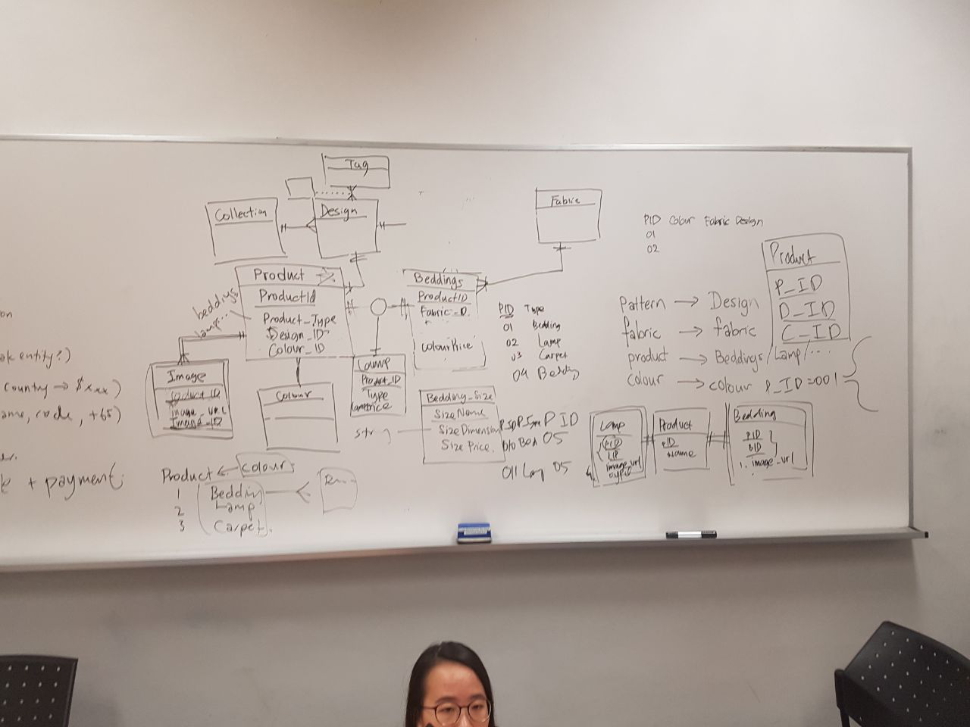

After soft delete database discussion

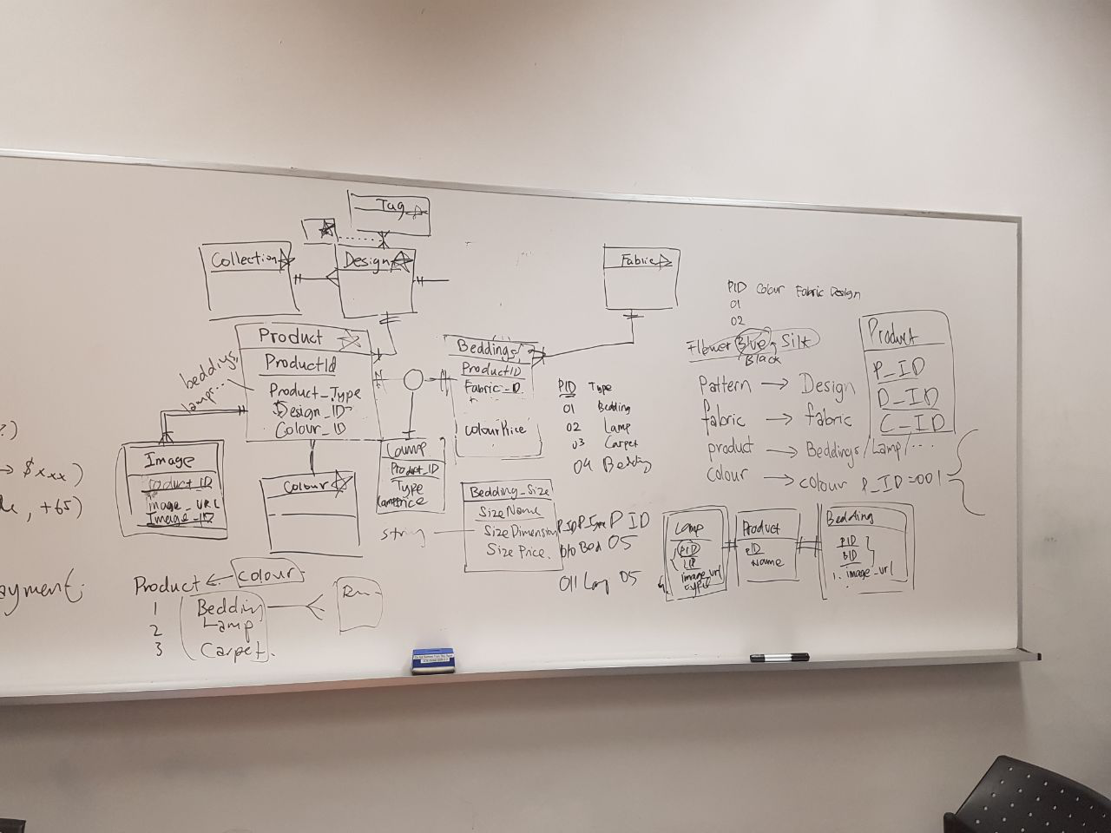

Counter (name, code +65)?

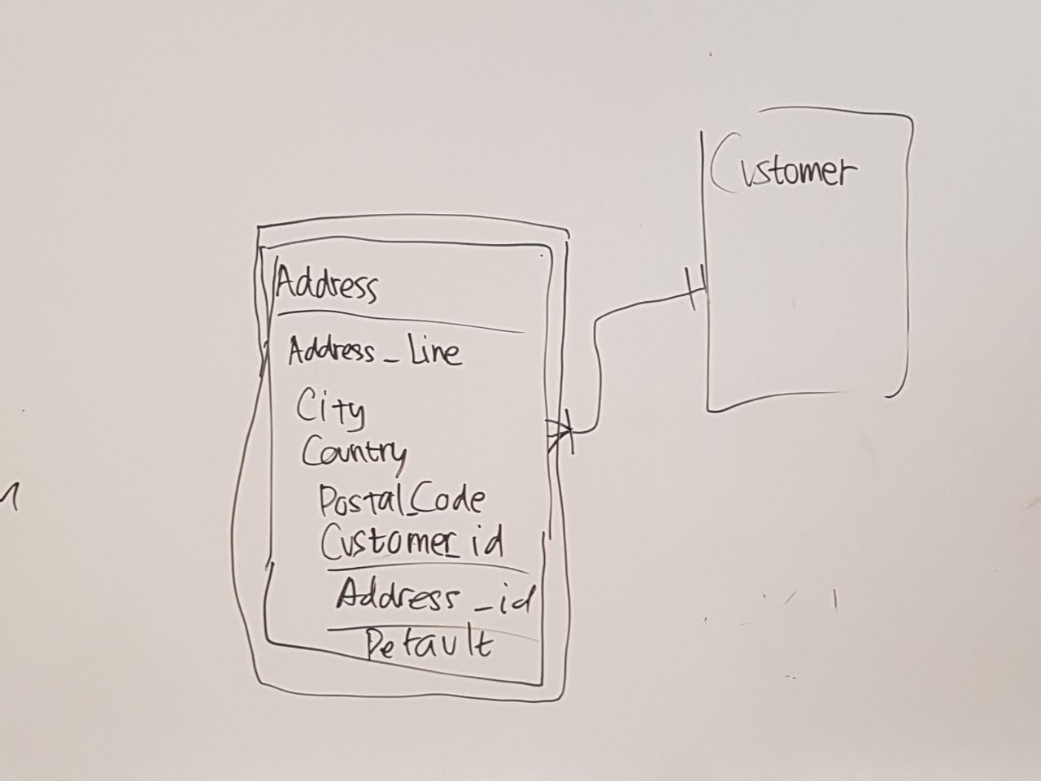

Multiple Address

Just let them store all the address they want (design like Adidas shop for dropdown list of add new address)

Promo Code

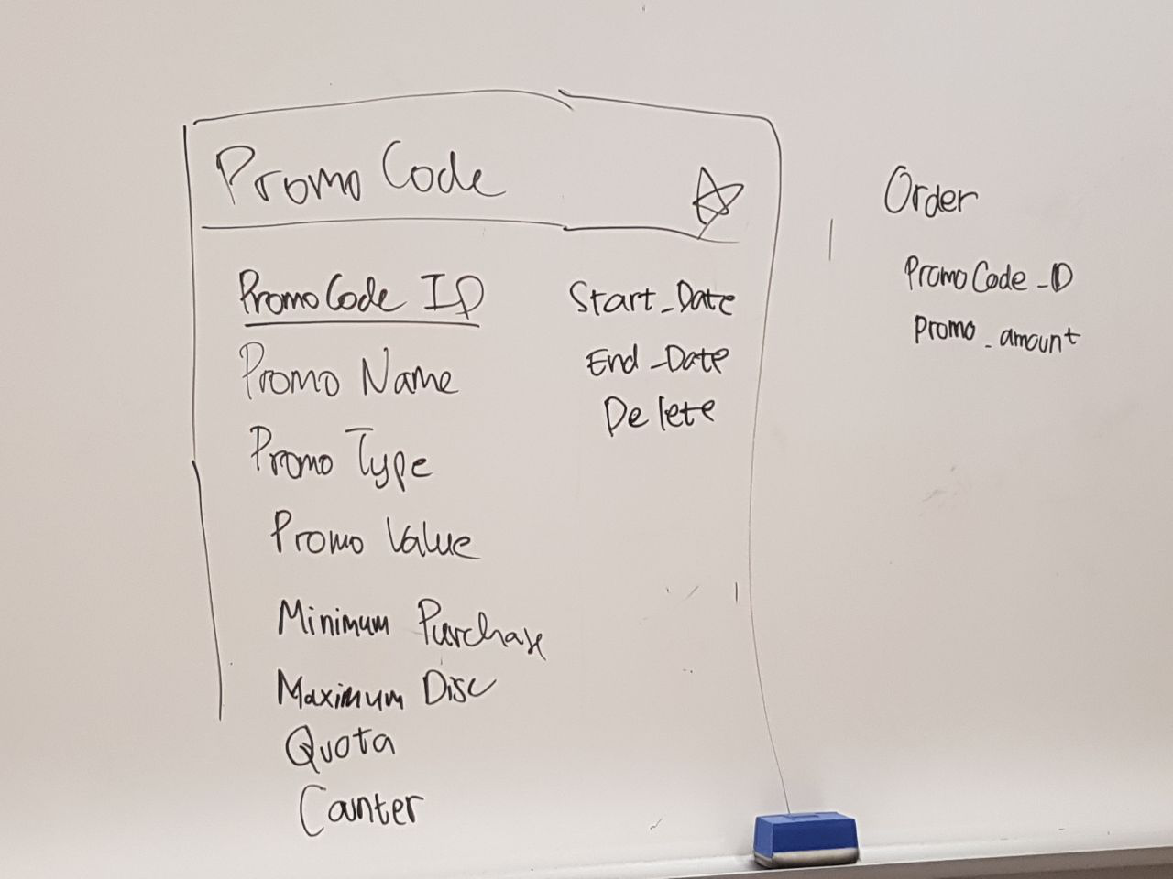

Track Order (refer to pointer 2/3/4) / Order Table + Payment

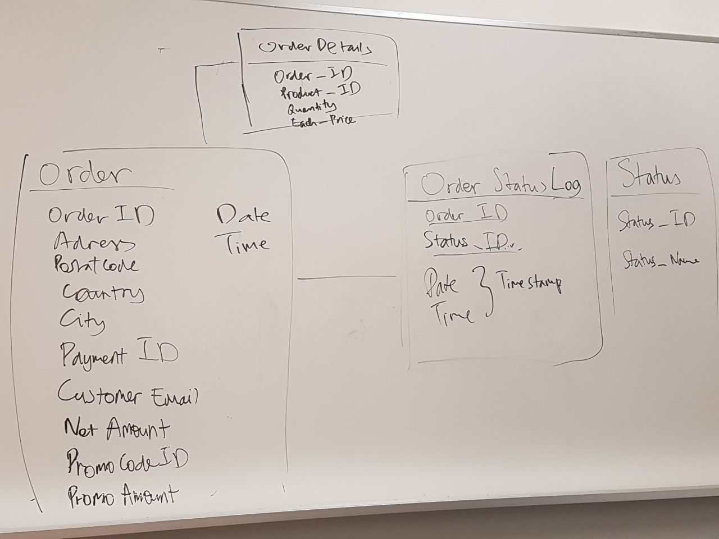

**2. Get from Sponsor the details of the 3rd Party shipper**

What are the shipping details he wants to transfer to our system? Do they have an API we can integrate on our system to show detailed shipper process? In China transit, in Singapore waiting delivery van etc.

**3. Get from Sponsor the details of the shipping across multiple countries**

In the future, when cost of shipping is considered, does shipping to different countries command a different price? (Letting country of shipping address be a consideration on shipping cost)

**4. Get confirmation of factory dashboard requirements from Sponsor**

Find Sponsor, Talk to Sponsor!

The meeting was adjourned at 3.30pm. These minutes will be circulated and adopted if there are no amendments reported in the next three days.

Prepared by,

Yi Xuan

Vetted and edited by,

Yu Xuan